Alzheimer's Disease Classification Using cnn: A Comprehensive Report

# **Submitted by**

# **Sahin Ali**

# **Sayak Nath**

# **PROJECT CERTIFICATE**

# **This is to certify that the Project entitled “ Alzheimer’s Disease Classification using CNN ” submitted by Sahin Ali, Sayak Nath, Jalpaiguri Government Engineering College, Jalpaiguri to the Electronics and Communication Sciences Unit, Indian Statistical Institute, Kolkata towards the partial fulfilment of the participation in the Ninth Summer School on Computer Vision, Image Processing, Machine Learning and Vision Language Models during June 18 – July 30, 2024. The entire project work is carried out by them under my supervision. The contents of this Project have not been submitted to any other Institute or University for the award of any degree or diploma.**

# **Susmita Ghosh**

**Senior Research Fellow**

**Electronics and Communication Sciences Unit**

**Indian Statistical Institute, Kolkata**

**Kolkata – 700108**

# **Place: Kolkata**

# **Date: 26/07/2024**

# **Abstract:**

Alzheimer's disease is an irreversible, progressive neurodegenerative disorder that destroys the brain and memory functionalities. In Alzheimer's disease, the brain starts shrinking, and over time it converts into dementia. The diagnosis of dementia takes an ample amount of time, around 2.8 to 4.4 years after the first clinical symptoms arise. Alzheimer's disease cannot be cured by any pharmacologic therapies (drugs) now on the market. Alzheimer's disease can only be avoided by early detection and prompt treatment. This paper proposes Convolutional Neural Network (CNN) models and Magnetic Resonance Imaging (MRI) images to detect the multiple stages of Alzheimer's disease such as "Very-Mild-Demented," "Mild-Demented," "Moderate-Demented," and "No-Demented." Data preprocessing is applied, enabling the model to detect the correct class of Alzheimer's disease. Then further, our proposed CNN model is used to classify and predict the early stages of Alzheimer's disease. It is observed that the model performs with an accuracy of 98.44%. We also developed an interface for real-world diagnostic processes.

# **1 Introduction:**

## **What is Alzheimer’s Disease (AD)?**

Alzheimer's is the most common cause of dementia, a general term for memory loss and other cognitive abilities serious enough to interfere with daily life. Alzheimer's disease accounts for 60-80% of dementia cases.Alzheimer's is not a normal part of aging**.** The greatest known risk factor is increasing age, and the majority of people with Alzheimer's are 65 and older.Alzheimer's worsens over time**.** Alzheimer's is a progressive disease, where dementia symptoms gradually worsen over several years. In its early stages, memory loss is mild, but with late-stage Alzheimer's, individuals lose the ability to carry on a conversation and respond to their environment. On average, a person with Alzheimer's lives 4 to 8 years after diagnosis but can live as long as 20 years, depending on other factors.

* 1. **Why we need to classify Alzheimer’s Disease?**

**Early Diagnosis and Intervention:** By analysing medical images such as MRI or PET scans, classifiers can detect subtle changes in brain structure or metabolism associated with Alzheimer's Disease at an early stage. Early detection allows for timely intervention and potentially better management of the disease progression.

**Objective Assessment:** Alzheimer’s Disease classification will provide an objective way to assess disease progression and severity. This reduces reliance on subjective evaluations, leading to more consistent and reliable diagnoses.

**Drug Development and Clinical Trials:** Image classification helps in identifying suitable candidates for clinical trials based on biomarker profiles. This improves the efficiency of drug development by selecting participants who are more likely to benefit from specific interventions.

* 1. **How does medical image classification work for Alzheimer’s Disease?**
     1. **Data Acquisition and Preprocessing:** First collect medical images, such as MRI scans or PET scans, are collected from individuals with Alzheimer's Disease, and healthy controls. Then the images undergo preprocessing steps to standardize the data, correct for artifacts, and normalize intensity levels.
     2. **Model Development:** Various deep learning architectures are employed. Then the selected model is trained using labelled datasets. The model learns to identify patterns or biomarkers in the images that distinguish between different classes.
     3. Model Evaluation**:** Evaluation metrics such as accuracy, sensitivity, specificity, and area under the receiver operating characteristic curve (AUC-ROC) are computed to assess the model's performance in classifying Alzheimer's Disease.
     4. **Clinical Application and Interpretation:** Once trained and validated, the model can be applied to classify new, unseen medical images into categories. Clinicians use these classifications as aids in diagnosis and treatment planning, especially in early detection and monitoring of Alzheimer's Disease progression.
     5. **Challenges and Considerations:** Availability of high-quality labelled datasets is crucial for training accurate models. Issues such as patient privacy, data security, and regulatory compliance must be addressed when implementing medical image classification in clinical practice.

## **Background study:**

The striking similarities between the structural brain imaging of a healthy individual and an Alzheimer's patient in the initial stages make Alzheimer's disease prediction a challenging issue. Detecting Alzheimer's disease in its initial stages can help elderly people stop the progression of the disease early. A detailed background study of Alzheimer's disease is mentioned in Table 1.

Background Study (Table 1)

|  |  |  |  |  |  |  |  |
| --- | --- | --- | --- | --- | --- | --- | --- |
| **Title** | **Dataset** | **Augmentation Technique** | **Model** | **Loss Function** | **Epochs** | **Performance** | **Remarks** |
| [1] Lightweight neural network for Alzheimer's disease classification using multi-slice sMRI | ADNI | No | ShuffleNet V1 | Cross entropy loss and triplet loss | 100 | AD, MCI, and CN- 95.00%, 87.5% and 85.62% Accuracy | Efficient model for multi-slice sMRI data to improve diagnostic speed and accuracy |
| [2] Multi-classification of alzheimer’s disease on magnetic resonance images (MRI) using deep convolutional neural network (DCNN) approaches | Custom dataset | Random Flip - Random Zoom | DCNN - CNN ,VGG-16 ,VGG-19 | Categorical Cross Entropy | 10 | Accuracy (%) 0.7102 0.7704 0.7766 |  |
| [3] DEMNET: A Deep Learning Model for Early Diagnosis of Alzheimer Diseases and Dementia From MR Images | Custom Dataset | randomly duplicating minority classes- with the random seed of 42 | DEMNET | The Root means square propagation (RMS prop) |  | 95.23% with SMOTE and 85% without SMOTE | Also used the ADNI dataset to predict AD classes.   80% training, 10% validation, and 10% testing |
| [4] Convolutional neural networks for Alzheimer’s disease detection on MRI images | ADNI | Rotation, scaling, flipping | CNN | |  | | --- | | Cross-  entropy |  |  | | --- | |  | | 50 | 96.88% accuracy | Used a 2D CNN on 3D MRI volumes |

## **3 Methodology:**

**3.1 Dataset Description:**

We used The Falah/Alzheimer_MRI Disease Classification dataset which is a valuable resource for researchers and health medicine applications. This dataset focuses on the classification of Alzheimer's disease based on MRI scans. The dataset consists of brain MRI images labelled into four categories:

* '0': Mild_Demented
* '1': Moderate_Demented
* '2': Non_Demented
* '3': Very_Mild_Demented

Fig 1. Mild Demented

Attached sample image from each category in Fig1, Fig2, Fig3, Fig4.

Fig 2. Moderate_Demented

**Dataset Information**

* Train split:
  + Total number of samples: 5,120
  + Label 0: 724
  + Label 1: 49
  + Label 2: 2566
  + Label 3: 1781
* 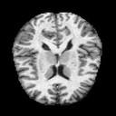Test split:
  + Total number of samples: 1,280

Fig 3. Non-Demented

* + **A close-up of a brain

    Description automatically generated**Label 0: 172
  + Label 1: 15
  + Label 2: 634
  + Label 3: 459

Fig 4. Very Mild Demented

* 1. **Data Preprocessing:**

The dataset was in Apache parquet format, which is an open source, column-oriented data file format. We converted this dataset into image format using cv2 for convenient.

Fig. 5 Test split graph Fig. 6 Train split graph

Loaded the MRI dataset: Started by loading the MRI data Alzheimer’s Disease into our programming environment. The dataset included a set of MRI images and corresponding labels indicating whether each image contains a specific label. Data exploration: Performed data exploration to understand the structure and characteristics of our dataset. Checked the image sizes, distribution of labels, and any preprocessing requirements specific to our dataset. Fig5 and Fig6 indicates number of images vs category label for test and train data.

* 1. **Architecture**

A Convolutional Neural Network (CNN) designed for image classification tasks. The architecture consists of several convolutional layers, max-pooling layers, a batch normalization layer, and fully connected layers. Below is a detailed breakdown of each component in the model:

**Input Layer:**

The model expects input images with a single channel (grayscale) and dimensions of 128x128 pixels.

**Convolutional Layer 1:**

This is a 2D convolutional layer with 32 filters, a kernel size of 3x3, and padding of 1. The input channel size is 1 (grayscale images), and the output channel size is 32. The purpose of this layer is to extract features from the input image.

Activation Function: ReLU (Rectified Linear Unit).

**Max-Pooling Layer 1:**

This is a max-pooling layer with a kernel size of 2x2 and a stride of 2. It reduces the spatial dimensions of the feature maps by a factor of 2.

**Batch Normalization Layer:**

This layer normalizes the output of the first convolutional layer to improve training stability and convergence speed. It has 32 features, matching the number of filters in the first convolutional layer.

**Convolutional Layer 2:**

This is another 2D convolutional layer with 64 filters, a kernel size of 3x3, and padding of 1. The input channel size is 32 (from the previous layer), and the output channel size is 64. This layer further extracts features from the feature maps obtained from the first convolutional layer.

Activation Function: ReLU.

**Max-Pooling Layer 2:**

This is another max-pooling layer with a kernel size of 2x2 and a stride of 2. It reduces the spatial dimensions of the feature maps by a factor of 2.

**Flatten Layer:**

This layer flattens the 3D feature maps into a 1D vector, which can be fed into the fully connected layers. The size of this vector is

64×32×32=65536.

**Fully Connected Layer 1:**

This is a fully connected (dense) layer with 128 neurons. It takes the flattened feature vector as input and produces a 128-dimensional output.

Activation Function: ReLU.

**Output Layer:**

This is the final fully connected layer with 4 output neurons, corresponding to the number of classes in the classification task. It takes the 128-dimensional vector from the previous layer and produces a 4-dimensional output representing the class scores.

* 1. **Visualization using Grad CAM**

Introduction:

Grad-CAM (Gradient-weighted Class Activation Mapping) is an advanced visualization technique that highlights the important regions of an image that influence the model’s decision. Unlike saliency maps, which focus on pixel-level importance, Grad-CAM operates on the feature maps of the last convolutional layer, providing a more interpretable and high-level visualization.

Explanation:

Grad-CAM works by first performing a forward pass to get the predicted class score. Then, the gradient of this score is calculated with respect to the feature maps of a target convolutional layer. These gradients are globally averaged to obtain a set of weights, which are then used to compute a weighted sum of the feature maps. This results in a coarse heatmap that highlights the important regions of the image. The heatmap is then upsampled to the size of the input image and superimposed to show which parts of the image are most influential for the prediction. Below attached an architecture of Grad Cam in Fig7-

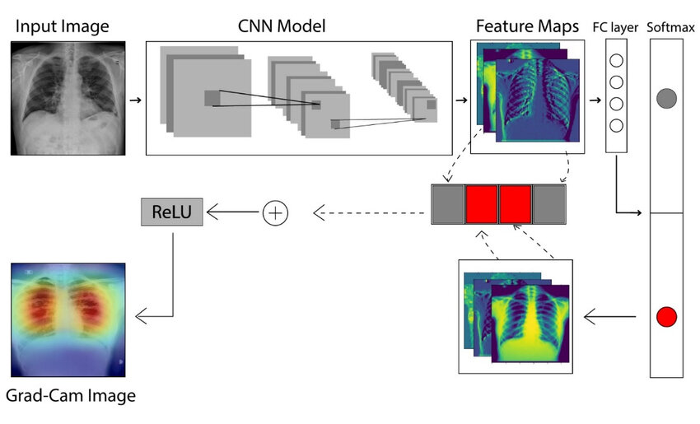

Fig. 7 Architecture of Grad CAM

Source:- <https://www.researchgate.net/figure/Architecture-to-describe-the-Grad-CAM-technique-36_fig6_354224316>

1. **Experiment and Result:**

**4.1 Loss function and Optimizer**

**Cross Entropy Loss:**

For our Alzheimer's MRI disease classification using a CNN, we use the Cross Entropy Loss function, ideal for multi-class classification. The true label for an MRI instance is a one-hot encoded vector **𝑦 = [ 𝑦1, 𝑦2, 𝑦3, 𝑦4 ],** and the predicted probabilities are **𝑞 = [ 𝑞1, 𝑞2, 𝑞3, 𝑞4 ].**

The Cross Entropy Loss is calculated as:

$$L\left(y,q\right)=-\sum_{i=1}^{4}{y_{i}}\log\left(q_{i}\right)$$

**Optimizer:**

We use the AdamW optimizer, which combines the adaptive learning rates of Adam with decoupled weight decay for better regularization. This optimizer helps in efficiently handling sparse gradients and improving generalization performance.

* 1. **Result:**

Models used:

* + 1. CNN (8408132 parameters)

Accuracy:

Training: 1.0000

Testing: 0.9844

A confusion matrix is a table that summarizes the performance of a classification model. It is a useful tool for understanding how well a model is classifying different classes. The confusion matrix is a square table with two dimensions: the actual class and the predicted class.

Training confusion matrix:

**Graph for CNN model:**

Graphs of Epoch vs Loss and Epoch vs Accuracy for the CNN model are plotted. Studying the graphs, it is clear that loss decays as number of epoch increases, and accuracy increases as number of epochs increases.

**Epoch vs Loss graph Epoch vs Accuracy graph**

* 1. **Interface:**

We developed an interface using flask (python framework), HTML, CSS. This interface can be used for prediction of Alzheimer’s disease class labels in real world diagnosis processes. Interface images given below in fig.8, fig.9.

**Fig.8 Interface Homepage**

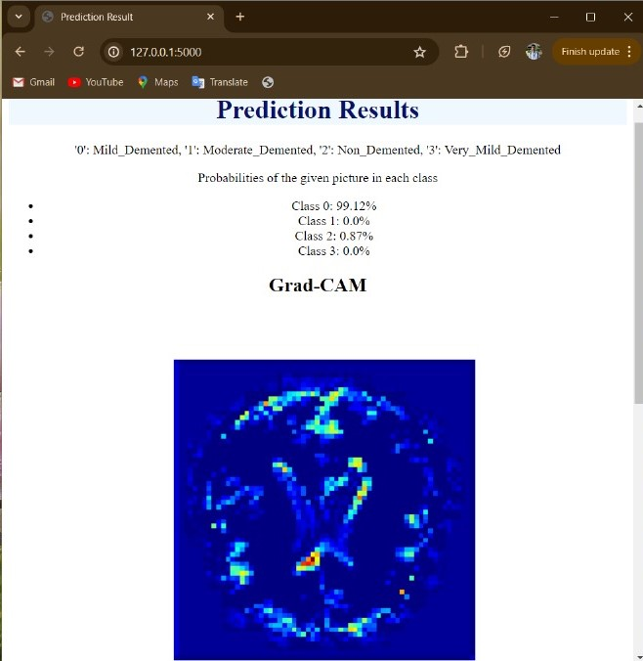

**Fig.9 Interface (Prediction Result)**

* 1. **Grad CAM image vs Original image:**

We tested Images from each category on our interface. Here are attached

images both original and Grad Cam from each category.

**Fig.10 Grad Cam image Fig.11 Original image**

**Moderate Demented-**Fig12, Fig13.

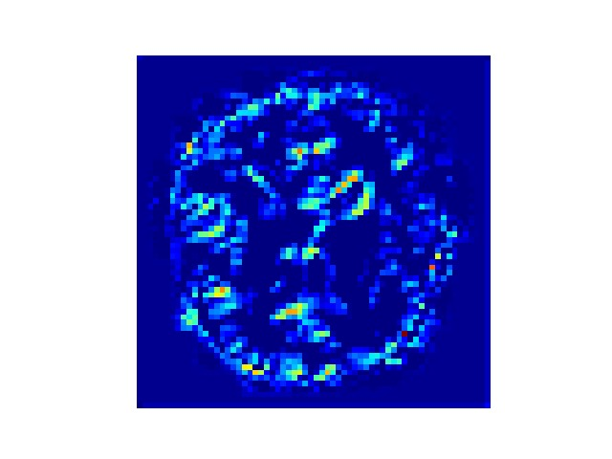

**Fig. 12 Grad Cam Image Fig. 13 Original Image**

**Non Demented-** Fig14, Fig15.

**Fig. 14 Grad Cam Image Fig. 15 Original Image**

**Very Mild Demented-** Fig16, Fig17.

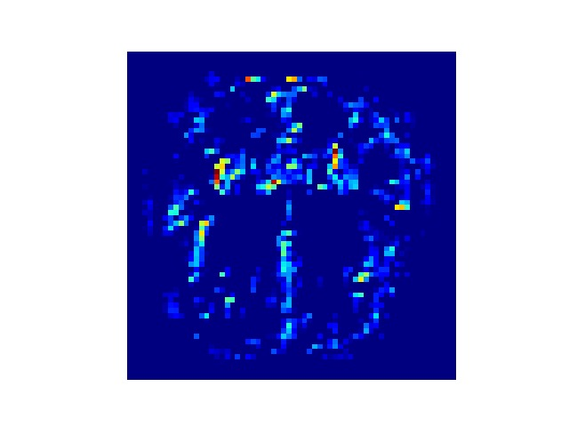

**Fig. 16 Grad Cam Image**

**Fig. 17 Original Image**

1. **Conclusion** 
   * The CNN model produced accuracy of 98.44% with 8408132 parameters.
   * According to the confusion matrix of the CNN model, 1 mild demented class images are misclassified to non demented class, 2 non demented class image is misclassified to mild demented class, 10 non demented class image is misclassified to very mild demented class, 5 very mild demented class image is misclassified to mild demented class, 1 very mild demented class image is misclassified to moderate demented class, 1 very mild demented class image is misclassified to non demented class.
   * From the graphs, it is clear that loss decays as number of epochs increases. And accuracy increases with number of epochs. Most of the misclassifications are mapped to non demented class.
   * Grad CAM is used on CNN model to highlights the important regions of an image that influence the model’s decision.
   * Developed user-friendly tools for clinicians to use the model in real-world diagnostic processes.
2. **Future Works**

**6.1. Data Augmentation:** Implement various data augmentation techniques to artificially balance the dataset. This can include rotations, translations, scaling, and flipping of images, which can help the model generalize better.

**6.2. Advanced CNN Architectures:** Experiment with more advanced and deeper CNN architectures such as ResNet, DenseNet, or InceptionNet, which could potentially improve classification accuracy.

**6.3 Multi-modal Data Integration:** Combine MRI images with other data sources such as clinical data, genetic information, and cognitive test scores to create a more comprehensive model.

**7.References**

1. Zhang, Qiongmin, et al. "Lightweight neural network for Alzheimer's disease classification using multi-slice sMRI." *Magnetic Resonance Imaging* 107 (2024): 164-170.
2. Ajagbe, Sunday Adeola, et al. "Multi-classification of Alzheimer disease on magnetic resonance images (MRI) using deep convolutional neural network (DCNN) approaches." *International Journal of Advanced Computer Research* 11.53 (2021): 51.
3. Murugan, Suriya, et al. "DEMNET: A deep learning model for early diagnosis of Alzheimer diseases and dementia from MR images." *Ieee Access* 9 (2021): 90319-90329.
4. Ebrahimi, Amir, Suhuai Luo, and for the Alzheimer’S. Disease Neuroimaging Initiative. "Convolutional neural networks for Alzheimer’s disease detection on MRI images." *Journal of Medical Imaging* 8.2 (2021): 024503-024503.